EXAMINATIONS
INFORMATION FOR STUDENTS AND PARENTS/CARERS



2026/27

 | 

CENTRE NO: 20827
In conjunction with this booklet please also look at the student tab on our website. Within this tab you will find a link to exams. Here there is more information from the Joint Council of Qualifications (JCQ) relating to the sitting of external exams and the completion of any internal work needed to complete the overall qualification.
Overall centre timetables for both external and internal assessment windows when available, will also be available here.
1 INTRODUCTION
It is the aim of Ormiston Shelfield Community Academy to make the examination experience as stress-free and successful as possible for all candidates.
Hopefully, this booklet will prove informative and helpful for you and your parents. Please read it carefully and show it to your parents so that they are also aware of the examination regulations and the procedures to follow in the event of any problems occurring. Keep it in a safe place so you can refer to it when needed. You can also find exam information in the Curriculum section of the school website.
The awarding bodies (or examination boards) set down strict criteria which must be followed for the conduct of examinations and Ormiston Shelfield Community Academy is required to follow them precisely. You should therefore pay particular attention to the awarding body notice ‘Warning to Candidates’ and other information in Section 5: Regulation Notices from page 15 onwards.
All personal data is supplied to and used by awarding bodies in accordance with the Data Protection Act 1998 and the Freedom of Information Act 2000 -see the Privacy Notice on page 21 for details.
Some of your queries may be answered in Section 6: Frequently Asked Questions.
If there is anything you do not understand or any question that has not been addressed, PLEASE ASK.
If you or your parents have any queries or need help or advice at any time before, during or after the examinations please contact Mrs D Dunne, Examinations Manager on 01922 685777 ext., 2105 or d.dunne@scacademy.co.uk
GOOD LUCK!
AWARDING BODIES (EXAMINATION BOARDS)
Ormiston Shelfield Community Academy uses the following awarding bodies: AQA, Pearson/Edexcel, OCR and WJEC. The body which oversees all Awarding Bodies and determines the regulations which apply is the Joint Council for Qualifications (JCQ). Should you wish to find more detailed information, such as timetables, their websites are listed below:
www.aqa.org.uk
www.edexcel.com
www.wjec.co.uk
www.ocr.org.uk
www.jcq.org.uk

2. EXTERNAL EXAMINATIONS
An exam that is not marked by teachers in the school but is instead dispatched to be marked by awarding body examiners is an external exam.
WHAT YOU NEED TO KNOW BEFORE THEY START!
STATEMENT OF ENTRY
All Candidates receive a Statement of Entry from school indicating the subjects they are being entered for and the tiers of entry, where applicable. You must check everything on your statement of entry very carefully, particularly your personal details, as these will appear on your certificates and there will be a cost for any changes once certificates are awarded. Any errors should be reported to the Exams Office.
CANDIDATE NUMBER
Each candidate has a four-digit candidate number. This is the number you will enter on examination papers. It will appear on your label on your exam desk.
UCI/ULN
In addition to the candidate number, each candidate has a Unique Candidate Identifier (12 numbers and 1 letter) and a Unique Learner Number; both are shown on your Statement of Entry.
TIMETABLES
You will receive an individual timetable showing your own specific examinations with
details of date, time, tier and duration of exam as well as the room and your seat number. Make sure you show your parents/carers and keep it in a safe place. You must check it carefully. If you think something is incorrect, see Mrs Dunne the Examinations Manager immediately.
A few candidates may have a clash where two subjects are timetabled at the same time. The school will make special timetable arrangements for these candidates only. If you think there is a clash on your timetable that has not been resolved, please see Mrs Dunne immediately.
An overall exam timetable is available on the school website, on the Learning Platform within the Exams tab, on the Examinations noticeboards and in the Exams Office.
CONTACT INFORMATION
It is essential that the school has at least one up-to-date contact phone number for parents/guardians in case of an emergency during an examination.
DURING THE EXAMS
EXAMINATION REGULATIONS
A copy of the “Warning to Candidates”, which is issued jointly by all the Awarding Bodies, is provided in Section 5: Regulation Notices. All candidates must read this carefully and note that to break any of the examination rules or regulations could lead to disqualification from all subjects. The school must and will report any breach of regulations to the Awarding Body. Also be careful when using social media and websites. These are monitored by awarding bodies and any comments in breach of regulations are considered as malpractice; see Section 5: Information for candidates -Guidelines when referring to exams/assessments through the Internet (social media).

ATTENDANCE AT EXAMINATIONS
Candidates are responsible for checking their own timetable and arriving at school on the correct day and time, properly dressed and equipped. Candidates must arrive 15 minutes prior to the start time of their examination.
Candidates who arrive late for an examination may still be admitted, but the Awarding Body will be notified. If there are exceptional circumstances, “special consideration” applies, and you must speak to the Examinations Manager (see ABSENCE FROM EXAMINATIONS).
Full School Uniform must be worn by all students attending school for examinations.
EQUIPMENT REQUIREMENTS
Pens (black), pencils, maths instruments, etc. You must either use a transparent pencil case or clear plastic bag. For Mathematics and Science exams, students should make sure their calculators are non-programmable and conform to the examination regulations. If in doubt, check with your teacher. Remove any covers or instructions and make sure batteries are new. Bags and coats must be put in the designated areas within each exam hall.

Mobiles or any other type of electronic communication or storage device are not allowed in the exam room. Any candidate found in possession of such a device will have it removed and will be reported to the awarding body, without exception. To this end, if you bring your mobile phone or other electronic device into school, for Year 11, this must remain in the pouch provided to you and in your bag at the back of the exam hall, and earphones, earbuds, smart glasses and all types of watches, will go into the numbered wallet on your exam desk. For 6th Form, mobile phones will also go into the wallet. The wallets have a number system whereby you will retain the number card from inside the wallet, which corresponds to the number on the front of the wallet your items are placed into. Items cannot be returned to students unless the corresponding number card is handed in.

Water bottles may be taken into the exam room but should be clear plastic with any labels removed. No food is allowed. Watches of any type must be placed on the desk in front of you. Examination regulations are very strict regarding items that may be taken into the examination room (see FAQs at the end of this booklet). If you break these rules, you will be disqualified from the examination.
INSIDE THE EXAM HALL
Do not attempt to communicate with or distract other candidates. Do not write on examination desks. This is regarded as vandalism, and you will be asked to pay for/repair any damage.
Do not draw graffiti or write offensive comments on examination papers – if you do the examination board may refuse to accept your paper.
Listen carefully to instructions and notices read out by the invigilators, as there may be amendments to the exam paper that you need to know about.
Check you have the correct question paper, check the subject, paper code and tier of entry. If in doubt raise your hand and an invigilator will come and assist, do not wait until the exam has started.
Read all instructions carefully and number your answers clearly.
Candidates must stay in the examination room for the duration of the exam. You will not be allowed to leave an examination room early. If you have finished the paper use any time remaining to check over your answers and that you have completed your details correctly.
At the end of the examination all work must be handed in – remember to cross out any rough work. If you have used more than one answer book or loose sheets of paper, please make sure that you insert these either in the question paper or answer book (as appropriate).
Invigilators will collect your exam papers before you leave the room. Absolute silence must be maintained during this time. Remember you are still under examination conditions until you have left the room.
Question papers, answer booklets and additional paper must NOT be taken from the exam room.
Remain seated in silence until told to leave the examination room. Please leave the room in silence and show consideration for other candidates who may still be working.
INVIGILATORS
The school employs external invigilators to conduct the examinations. Students are expected to behave in a respectful manner towards all invigilators and always follow their instructions.
Subject specialist teachers may be present at the start of an examination only, and for MFL Listening exams.
Invigilators are in the examination rooms to supervise the conduct of the examination. They will distribute and collect the examination papers, tell candidates when to start and finish the examination, hand out extra writing paper if required and deal with any problems that occur during the examination, for example if a candidate is feeling ill.
Please note that invigilators cannot discuss the examination paper with you or explain the
Questions.
Pupils who are disruptive or behave in an unacceptable manner will be removed from the examination room by the Exams Manager and members of the Senior Management Team.
Remember that any case of suspected inappropriate behaviour must be reported to the Awarding Body.
FIRE ALARM/BOMB ALERT PROCEDURE
If a fire alarm sounds during an exam, remain seated and listen carefully to the instructions from the invigilators. If it is necessary to evacuate the examination room, you will be asked to leave in silence. Leave everything on your desk, close your examination paper and you will be escorted out one row at a time in seat order, to the designated assembly point away from other members of the school.
YOU MUST NOT ATTEMPT TO COMMUNICATE WITH OTHER CANDIDATES. ANY BREACH OF THIS REGULATION MUST BE REPORTED TO THE AWARDING BODY AND WILL NORMALLY RESULT IN DISQUALIFICATION.
Provided that you can return to the room later, you will be given the full time allocated. The Awarding Body will be informed of the disruption.
ABSENCE FROM EXAMINATIONS
If you experience difficulties during the examination period (e.g. illness, injury, and personal problems) please inform school at the earliest possible point so we can help or advise you.
Only in ‘exceptional circumstances’ are candidates allowed special consideration for absence from any part of an examination. It is essential that medical or other appropriate evidence is obtained on the day by the candidate/parent/guardian and given to the Examination Officer without delay in all cases where an application is to be made for special consideration.
Parents and candidates are reminded that the school will require payment of entry fees (£50 per subject) should a candidate fail to attend an examination without good reason and without informing the school.
Failure to pay may result in your examination results being withheld. Please note that misreading the timetable will not be accepted as a satisfactory explanation of absence.
WHAT TO DO IF YOU ARE ILL ON THE DAY OF AN EXAM!
If you are ill and are unable to attend an exam it is vital you or your parent/carer phone the school first thing in the morning (01922 685777) to inform us.

You must also obtain a note from your doctor detailing the reason for non-attendance. There is the possibility of submitting this note to the Examinations Board to ask for special consideration. The Board looks at this in conjunction with other exam marks from the student in that subject, coursework marks and mock exam marks. This will then sometimes enable them to adjust the mark and grade accordingly.

If you are feeling unwell, but still able to travel, it is best for you to come into school for the exam, and we can assess the situation then. In most cases it is better to take the exam if you can.

If in doubt – PHONE THE SCHOOL

If you do not attend an exam without a valid reason, it is possible that you will be charged for that exam.
FORBIDDEN ITEMS
Once in the Exam Room you are not allowed to use or be in possession of …
- a mobile phone or watch
- any other electronic or web-enabled storage device facility
- any of your own paper or notes, or any material which might be deemed to be of help to you
- bags / coats (so these will be stored away from you in the room)
- correcting fluid, ink eraser pens, gel-pens

REMEMBER


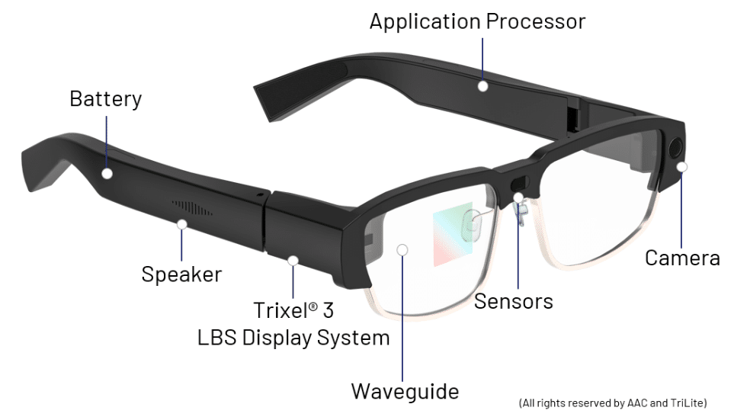


IF YOU ARE CAUGHT WITH ANY OF THE ABOVE IN ANY EXAM IT COULD RESULT IN
DISQUALIFICATION
FROM THE CURRENT EXAM AND THE OVERALL QUALIFICATION
3. NON-EXAMINED ASSESSMENTS (NEA)/COURSEWORK
NEA/Coursework assessments form a compulsory part of some qualifications. They are internal assessments where tasks are completed over time, in school, under strict conditions and marked by teachers. Deadlines will be set at various stages throughout the year AND MUST BE ADHERED TO. If you have difficulty in completing such assignments, you must talk to your subject teacher or Head of Year sooner rather than later, so that help and support can be given.

We wish to bring to your attention concern being expressed by the Awarding Bodies regarding the authenticity of NEAs/Coursework submitted by students at all levels of the system.
In an effort to combat this, the Boards require all candidates to sign a form confirming the
authenticity of each separate piece of work submitted. This means that, not only is the work that of the individual alone, but that all sources (books, films, journals AND internet sites and AI) have been acknowledged. It is also important to note that awarding bodies monitor social media and websites, so be very careful what you may say – more information can be found in Section 5: Regulation Notices under Information for candidates – social media.

In the interest of fairness to all candidates sitting examinations, we would ask parents to do their best to ensure that their son/daughter is clear about this, and that they are aware of the possible implications of any attempt to submit work which is not their own, either wholly or in part.
Neither copying the work of another student nor allowing your work to be copied is acceptable. Both practices constitute infringements of the rules which will be sanctioned by disqualification.
The Boards are likely to disqualify anyone caught cheating, certainly from the examination concerned and, possibly, from the whole series
(i.e. all examinations taken).
We too, as guardians of the integrity of the examination process at Ormiston Shelfield Community Academy, are likely to take a very dim view of anyone found guilty of deception. Any re-taking of examinations at a later stage will be at the expense of the individual candidate, not of the school.
Full details can be found in Section 5 of this booklet. Information around the use of AI in assessments can also be found on the following page.

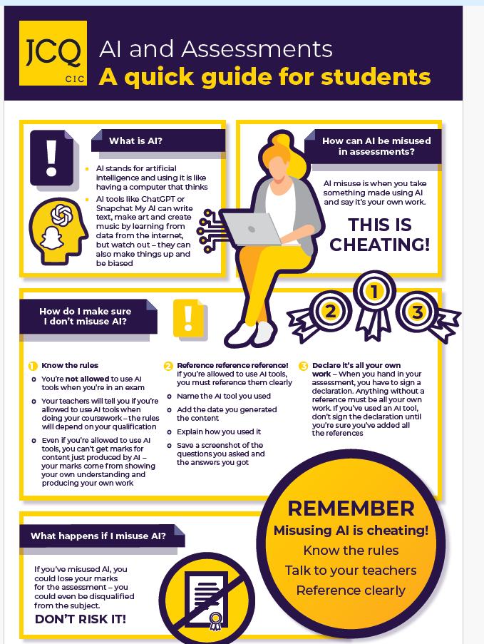
APPEALS ABOUT INTERNAL ASSESSMENT DECISIONS
Ormiston Shelfield Community Academy is committed to ensuring that internal assessments are marked and administered fairly, consistently and in accordance with the awarding body specifications and subject-specific associated documents.
This is ensured by:
- Subject staff having the necessary and appropriate knowledge, understanding, skills, and training in this activity
- Subject staff authenticating candidates’ work according to the requirements of the relevant awarding body
- A process of internal moderation and standardisation led by Heads of Department/nominated subject staff

An appeal against internal assessment decisions can be made, based on the above not being fulfilled.
All appeals must follow the procedure detailed below.
Note -appeals may only be made against the marking/assessment process not against the mark submitted by the centre for moderation by the awarding body.
- Appeals should be made as early as possible and at least two weeks before the end of the last externally assessed paper in the examination series (e.g. the last GCSE written paper in the summer exam series)
- Appeals should be made using the internal appeals form completed by the candidate (or parent/carer)
- The head of centre will appoint a member of the senior leadership team, who is not involved in the assessment process for that subject to conduct the investigation
- The purpose of the appeal will be to decide whether the process used for the internal assessment conformed to the published requirements as detailed in the awarding body specification(s) and/or subject-specific associated documents
- The appellant will be informed in writing of the outcome of the appeal, including any relevant correspondence with the awarding body and any changes made to internal assessment procedures
- The outcome of the appeal will be made known to the head of centre and will be logged as a complaint. A written record will be kept and made available to the awarding body upon request. Should the appeal bring any significant irregularity in procedures to light, the awarding body will be informed

After candidates’ work has been internally assessed, it is moderated by the awarding body to ensure consistency in marking between centres. The moderation may lead to mark changes. This process is outside the control of Ormiston Shelfield Community Academy and is not covered by this procedure.
4. RESULTS AND BEYOND
NOTIFICATION OF RESULTS
November re-sit Results will be issued Thursday 8th January 2026.
Summer Results will be issued on the morning of Thursday 12th August 2026 for A Level and other Level 3 Qualifications and on the morning of Thursday 19th August 2026 for GCSE and other Level 2 Qualifications.
If you wish any other person (including family members) to collect your results on your behalf, you must give your written authorisation to school before results day, and they should bring ID with them. Candidates who cannot collect their results on that day will need to supply us with a stamped addressed envelope for the results to be posted.
No results will be given out by telephone under any circumstances.
The Examinations Manager, Director of Sixth Form and members of our Senior Leadership team are available on Results Day to assist you with any additional queries that you may have.
POST RESULTS SERVICES
We do hope that you achieve the results you are expecting and that your hard work deserves. Unfortunately, it is inevitable that some of you will be disappointed with your grades. The following information has been written to give you guidance on the post results services available to you. Please make sure you read it carefully; there are some key dates which you must ensure that you do not miss. RE-MARK Generally, it is not worth considering a remark of an examination paper that is more than one or two marks away from the grade border. We would recommend that you always discuss this option with your subject teacher before you make a request for a remark. You must make the request through the school, and you have until the 12th of September to make any request for a remark.
Please bear in mind that if you request a re-mark, your grade could go down as well as up, although this is unlikely if the mark is just below the higher grade.
Occasionally the school will decide to challenge a result, and we will contact you by email or phone either on results day or in early September to ask for your consent to a remark.

CLERICAL CHECK
This service checks totalling of marks, the recording of marks, the application of grade thresholds etc. Requests for a clerical check must be received by 12th September.
RESITS
Ormiston Shelfield Community Academy does not normally enter former pupils for English and Maths resits in November.
CERTIFICATES
Certificates will be available for collection from the Exams Office in December. Certificates need to be signed for and we do not post them out. It is your responsibility to come and collect them.

It is important to store your certificates in a safe place, as you may be required to show them to colleges, universities and future employers.
Ormiston Shelfield Community Academy is only obliged to retain certificates for one year from the date of issue. Candidates who do not collect their certificates within this time (or if they lose their certificates) must apply directly to the appropriate awarding bodies for a Certifying Statement of Results. This will require proof of identity (such as a birth certificate) and a substantial fee.

You are therefore urged to collect your certificates from December onwards.



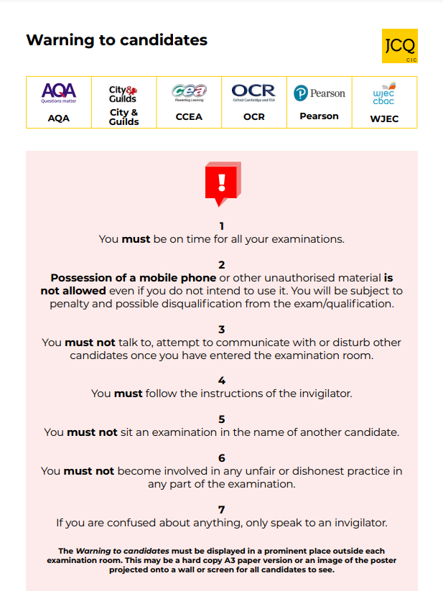
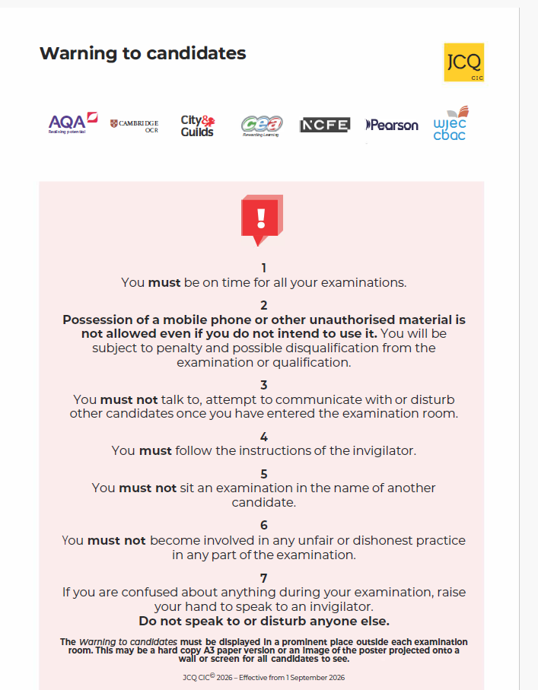

6. FREQUENTLY ASKED QUESTIONS

Why do I need to check the details on the Statement of Entry?
The details on your Statement of entry will be used when certificates are printed. If the name or date of birth on your certificates does not match your birth certificate it could cause you problems if you are asked to show your certificates to a potential employer or college/university at some time in the future. You should also check that the subjects and tiers of entry you are entered for are correct and that no subjects are missing.

What do I do if there is a clash on my timetable?
The school will re-schedule papers internally (on the same day) where there is a clash of subjects. Candidates will normally sit one paper then have a supervised break of a few minutes. They will then sit the second paper. Adjusted times would be shown on your individual candidate timetable. If your timetable has been adjusted the Examinations Manager will advise you of arrangements for that day.

What do I do if I have an accident or am ill before the exam?
Inform the school at the earliest possible point so we can help or advise you. It is necessary to obtain medical evidence from your GP or the Hospital, and the Examinations Manager will need this to enable Special Consideration to be applied for (see below).

What is an Appeal for Special Consideration?
Special Consideration is an adjustment to the marks or grades of a candidate who is eligible for consideration. The allowance for Special Consideration is from 0% (consideration given but addition of marks considered inappropriate) to 5% (reserved for exceptional cases). Parents should be aware that any adjustment is likely to be small, and no feedback is ever provided. Candidates will only be eligible for Special Consideration if they have been fully prepared and covered the whole course but either their performance in the examination or in the production of controlled assessments has been affected by adverse circumstances which were beyond their control. Examples of such circumstances may be illness, accident or injury, bereavement or domestic crisis. The Examinations Manager must be informed immediately, so that the necessary paperwork can be completed. Please note that the candidate will be required to provide evidence to support such an application.

Do I have to wear school uniform in an exam?
Yes, normal school regulations apply.

What equipment should I bring for my exams?
You should bring at least 2 pens (black ink only), a pencil, ruler, compass, protractor, coloured pencils, pencil sharpener, rubber and highlighters to highlight questions where appropriate. You should also bring a Scientific Calculator for use in those exams where a calculator is permitted.

Can I bring food and drink into an exam?
You can only bring a water bottle into an exam from which the label must be removed.

How do I know how long the exam will be?
The length of the examination is shown in minutes on your individual timetable under the heading ‘Duration’. The Exams Manager or an Invigilator will tell you when to start and finish the exam. They will write the start and finish time of each examination on the Whiteboard at the front of the room. There are clocks in several places in the examination room. These clocks will be analogue clocks.

If I am late, can I still sit the examination?
Provided you are not more than one hour late; it may still be possible for you to sit the examination. You should get to school as quickly as possible and report to Reception. A member of staff will escort you to the exam room. You must not enter and examination room without permission after an examination has begun.

You should also be aware that if you start the exam more than 30 minutes after the published starting time, the school must inform the Awarding Body, and it is possible that they may decide not to accept your work. Please ensure that you allow enough time to get to school so that if you are delayed (e.g. through transport problems) you will still arrive on time.

If I miss an examination can I take it on another day?
No. Timetables are regulated by the exam boards, and you must attend on the given date and time.

What do I do if I feel ill during the exam?
Put your hand up and an invigilator will assist you. You should inform an invigilator if you feel ill before or during and exam and you feel this may have affected your performance.

What do I do if I think I have the wrong paper?
The Examinations Manager or an Invigilator will ask you to check before the exam starts. If you think something is wrong put your hand up and tell the invigilator immediately.

What do I do if the fire alarm goes?
The invigilators will tell you what to do. If you must evacuate the room, leave everything on your desk and leave the room in silence. You must not attempt to communicate with any other candidates during the evacuation.

Can I go to the toilet during the exam?
If it is necessary. You will be escorted by an invigilator and will not be allowed any extra time.

Can I leave the exam early?
No. It is not the school’s policy to allow candidates to leave the exam room early, as this is disruptive to other candidates. A candidate may not leave the examination room without the permission of the invigilators.

If I am unhappy with my exam result, can I have it re-examined?
If you have concerns you should discuss these as soon as possible either on results day or as near to results day as is possible, with your subject teacher. It may be possible to request a remark.

Will I need my certificates?
Yes!!! It is very likely that your future colleges, universities or employers will request sight of your certificates. It is very important that you collect your certificates and keep them in a safe place. Certificates are generally available from the Examinations Office towards the end of the year in which you receive your results. Please note that it is your responsibility to collect these certificates which must be signed for. The Examinations Office is only legally expected to keep them for one academic year.

