

**BTEC Level 3 Sport Studies**



**Summer Transition Booklet**

Name………………………………………..

**Introduction**

The Level 3 National Diploma in Sport is equivalent in size two A levels. In year one you will study 5 Units. Two are externally assessed and three are internally assessed.

The 3 mandatory units are:

**Unit 1 - Anatomy and Physiology**

Unit size: 120 hours

Assessed: External exam. 90 minutes

**Unit 2 - Fitness Training and Programming for Health, Sport and Well-being**

Unit size: 120 hours

Assessed: Will be assessed under supervised conditions. Learners will be given a case study one week before the supervised assessment period to carry out preparatory work. Student will then be given a task on the case study lasting up to 2.5 hours.

**Unit 3 - Professional Development in the Sports Industry**

Unit size: 60 hours

Assessed: Internal Coursework and Video Footage

The 2 other units are:

**Unit 5 – Application of Fitness Testing**

Unit size: 60 hours

Assessed: Internal Coursework and Video Footage

**Unit 23 - Skill Acquisition in Sport**

Unit size: 90 hours

Assessed: Internal Coursework and Video Footage

The summer transition booklet will help you prepare for unit 1, 2, 3 and 5.

**UNIT 1 - Anatomy and Physiology**

**Types of Joints & Bones**

Research the following types of Joints:

* Where these joints are found
* What their structure is
* What movements can occur there
* An example of a sporting movement where the joint would be used

|  |  |
| --- | --- |
| Condyloid: | Gliding: |
| Saddle: | Pivot: |

|  |  |
| --- | --- |
| **Type of Bone** | **Location in the body** |
| Long |  |
| Short |  |
| Flat |  |
| Irregular |  |
| Sesamoid |  |

**Postural deviations**

The 2 images below show 2 types of postural deviations. A postural deviation is when the natural curve of the spine is changed. Next to each image describe the type of postural deviation (what it is/looks like & what causes it).

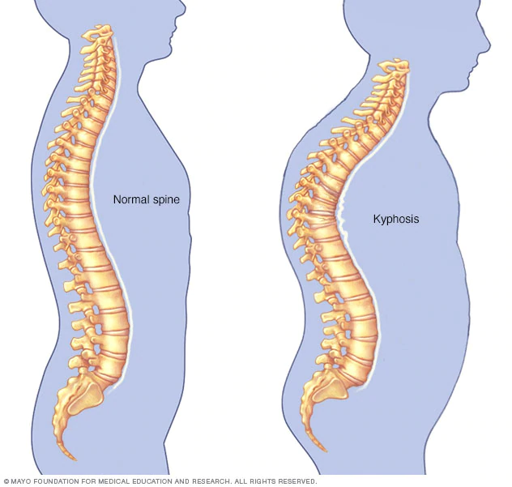

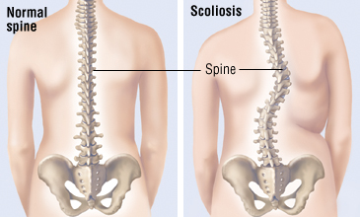

**Types of Muscle**

There are 3 types of muscle fibre; Type I, Type IIa, Type IIx. Research all 3 types giving their alternative name and then explaining what their characteristics and capabilities are as well as what sports they would be used in, when and why.

|  |  |
| --- | --- |
| Type I: |  |
| Type IIa |  |
| Type IIx |  |

**Lung Volumes**

Below is an image of the lung volumes which are measured by a spirogram. Underneath explain what each one is and give the normative value for an average adult including the correct unit of measurement.

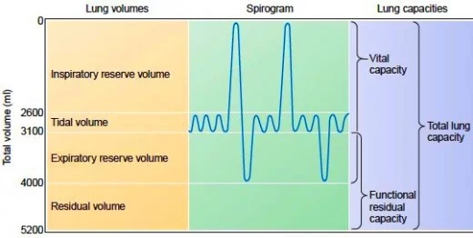

**Altitude Training**

Research what altitude training is, include the following:

* What it involves
* What happens as a result of it
* How it is beneficial
* What type of sports people would it benefit the most

**Sudden arrhythmic death syndrome (SADS)**

Research the condition SADS, include the following:

* What it is/why it happens
* Examples of SADS that have occurred in sports people
* What is being done to prevent it?

**Practice Assessment Questions**

**Assessment Practice 1.1**

1. Explain how the bones of the skeleton are used in movement for sport. **(2 marks)**

2. Jack has the first stages of osteoporosis. He has been advised to take part in exercise to help prevent this condition from worsening. Identify one type of exercise that Jack could take part in to prevent the osteoporosis from getting worse. **(1 mark)**

**Assessment Practice 1.2**

1. Two days after Nancy’s training session she experiences delayed onset of muscle sorene4ss (DOMS). Describe why Nancy’s training may cause DOMS. **(1 mark)**
2. Explain how muscle adaptation occurs as a result of Nancy’s resistance training. **(2 marks)**

**Assessment Practice 1.3**

1. Explain the short-term effect of taking part in football on Freddie’s tidal volume. **(3 marks)**
2. Explain the role of carbon dioxide in the chemical control of breathing during exercise. **(3 marks)**

**Assessment Practice 1.4**

1. Grace is a basketball player. The table shows Grace’s heart rate at rest and then one minute before taking part in regular basketball for over 8 months. In this time Grace’s resting heart rate has decreased from 77 to 70 bpm. Explain why Grace’s resting heart rate has decreased. **(3 marks)**

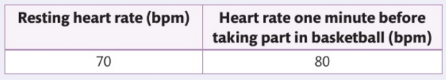

**UNIT 2 – Fitness Training and Programming for Health, Sport and Well-being**

*In this unit, you will explore the process required for screening clients and assessing their lifestyle and nutritional intake. How to interpret this information will then be examined; from this information you will explore how to make judgements on a specific individual’s current lifestyle and then suggest modifications to help improve the individual’s fitness, health and overall well-being.*

Key source – NHS one you, <https://www.nhs.uk/live-well/>

<https://www.verywellhealth.com/lifestyle-factors-health-longevity-prevent-death-1132391>

There are a number of key lifestyle factors that impact on health and well-being. Use a variety of sources (websites, journals, magazines, television, and newspapers) to read about each lifestyle factor and make some notes on the factor for a variety of ages groups and different genders:

- Physical Activity

|  |  |
| --- | --- |
| Diet and Nutrition | Smoking |
| Alcohol consumption | Sleep |
| Stress |  |

What are the recommended guidelines relating to each of the Lifestyle Factors? (Record your source)

What are the consequences or risks of not meeting the guidelines for each Lifestyle Factor?

**UNIT 3 – Professional Development in the Sports Industry**

*In this unit, you will research the different possible careers and the associated job roles in the sports industry, then action plan your development towards achieving a selected career aim. You will analyse your own skills and identify how to develop them into a career through the use of a career plan. You will research your chosen career to understand how to access and progress within it.*

Task 1: Read the “Economic value of sport document” at the back of this transition booklet. From this document you will understand the significant role sport plays in society. Use the box below to report what you have learnt. Please provide a minimum of 5 statements.

|  |
| --- |
|  |

Task 2: Read the “economic value of sport- West Midlands” at the back of this booklet. From this document you will understand the significant role the sport plays where we live. Use the box below to report what you have learnt. Please provide a minimum of 5 statements.

|  |
| --- |
|  |

Task 3: A significant part of this unit is that you understand jobs within the sports and leisure industry. Please spend 15 minutes and create a list of 20 roles in the sports and Leisure industry. I have provided some examples.

|  |  |  |  |
| --- | --- | --- | --- |
| 1 |  | 11 |  |
| 2 |  | 12 |  |
| 3 |  | 13 |  |
| 4 |  | 14 |  |
| 5 |  | 15 |  |
| 6 |  | 16 |  |
| 7 |  | 17 |  |
| 8 |  | 18 |  |
| 9 |  | 19 |  |
| 10 |  | 20 |  |
|  |  | 21 | Lifeguard |
|  |  | 22 | Sports Biomechanist |

Task 4: The main piece of work that you will have to compete for Learning Aim A is describing the pathway into two jobs/careers that interest you. You should choose a 2 jobs/careers that you can see yourself doing in a few years to come. I would recommend you choose one job/career which involves some form of higher education or training. This will give you an opportunity to make your work more extensive. If you were to choose something like a lifeguard for instance you only really need one qualification (National Pool Lifeguard Qualification). As a result, you wouldn’t have much to write about. If you were to go for a career such as a PE Teacher, Sports Nutritionists or Sports Physiotherapist you would be able to provide lots more information making Learning Aim A easier to complete.

See my PE teacher example and then complete the two pages below. One page for each job/career totalling 2 jobs/careers.

**Example**

**Job/Career 1: PE Teacher at Shelfield Community Academy**

**Job description: To deliver core PE lessons, GCSE and A level PE and BTEC Level 2 and 3 to students between the ages of 11-18.**

**Job opportunities: This job will give me the opportunity to work with the next generation of society. It will give me the opportunity to take students abroad on ski trips or sports tours. In terms of progressional I could also become a Head of Department or Assistant Headteacher**

**What work experience could you do now to enhance skills/knowledge relevant to that career:**

**Help to coach Pelsall Villa U9s. This will increase my confidence and develop my leadership skills.**

**Work at a youth club. This will improve my ability to work with young people.**

**Get a placement working in a PE dept at Shire Oak or Aldridge. This will give me an opportunity to understand how a PE department works in preparation for the future.**

**Educational pathway (6th Form/college, apprenticeship, Degree, Masters, Doctorate):**

**6th form or college to do a Level 3 related course. For example BTEC or Alevel Pe**

**Univeristy to do a degree in a sports related course. For example BSc Sports Science.**

**Masters in Education after a few years of teaching**

**Qualifications separate to those gained through educational pathway:**

**Coaching qualifications (e.g. FA level 1, Basketball England Level 1)**

**Child protection course**

**First Aid course**

**General skills needed:**

**Communication**

**Leadership**

**Team Work**

**Empathy**

**Positivity**

**Specific skills needed (which other jobs/careers wouldn’t):**

**Marking work**

**Teaching**

**Completing registers**

**Behaviour management**

**Poviding information at parents evening**

**Regulatory bodies:**

**General Teaching council**

**Association for PE**

**Job/Career 1:**

**Job description:**

**Job opportunities:**

**What work experience could you do now to enhance skills/knowledge relevant to that career:**

**Educational pathway (6th Form/college, apprenticeship, Degree, Masters, Doctorate):**

**Qualifications separate to those gained through educational pathway:**

**General skills needed:**

**Specific skills needed (which other jobs/careers wouldn’t):**

**Regulatory bodies:**

**Job/Career 2:**

**Job description:**

**Job opportunities:**

**What work experience could you do now to enhance skills/knowledge relevant to that career:**

**Educational pathway (6th Form/college, apprenticeship, Degree, Masters, Doctorate):**

**Qualifications separate to those gained through educational pathway:**

**General skills needed:**

**Specific skills needed (which other jobs/careers wouldn’t):**

**Regulatory bodies:**

**Unit 5 – Application to Fitness Testing**

*In this unit, you will explore the principles of fitness testing and examine the factors affecting the selection and administration of tests, including validity, reliability and suitability of tests. You will explore a range of laboratory and field-based fitness tests and the administration process of each fitness test. You will consider the selection of appropriate tests for specific sports performers, and demonstrate your ability to conduct a range of fitness tests in accordance with the safety and ethical requirements of fitness testing.*

1. Why is fitness testing important?
2. Define validity of fitness testing.
3. Define reliability of fitness testing.
4. Define practicality of fitness testing.
5. Define suitability of fitness testing.
6. Define the ethical considerations associated with fitness testing.
7. Name two appropriate fitness tests to measure the 11 fitness components:

Physical Fitness Components

Flexibility



Aerobic Endurance



Muscular Endurance



Muscular Strength



Body Composition



Speed



Skill-Related Fitness Components

Coordination



Reaction Time



Agility



Balance



Power