



**BTEC Level 3 National Diploma in Business**

Transition Task

2025

# Newspaper Article Review

Throughout your course you will be using newspaper, magazine or website articles which are relevant to the module you are studying.

Use the following strategy to analyse the article:

Brief description of news item

Central problem (what are the main issues?)

Internal Analysis (strengths and weaknesses of the business)

External analysis (opportunities and threats outside of the business)

Solutions proposed? (theirs and yours)

Evaluation (advantages and disadvantages of solutions)

**After analysing the article on PLT, find another business scenario to analyse in the same way. Bring these two pieces of work to your first business lesson or email** [**a.mwansa@scacademy.co.uk**](mailto:a.Mwansa@scacademy.co.uk)

Good source of articles: <http://www.bbc.co.uk/news/business>

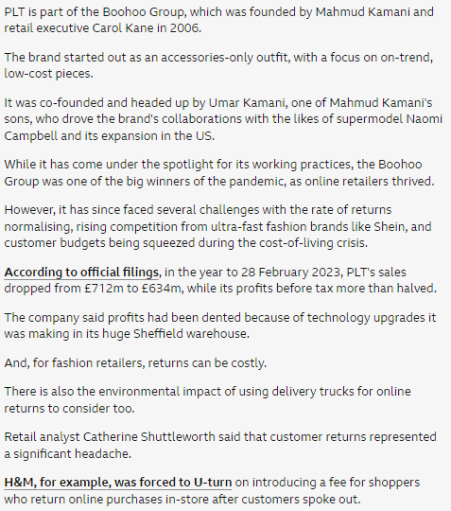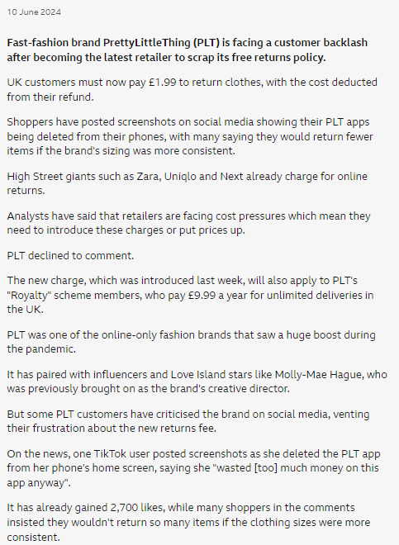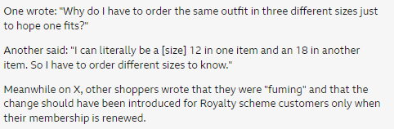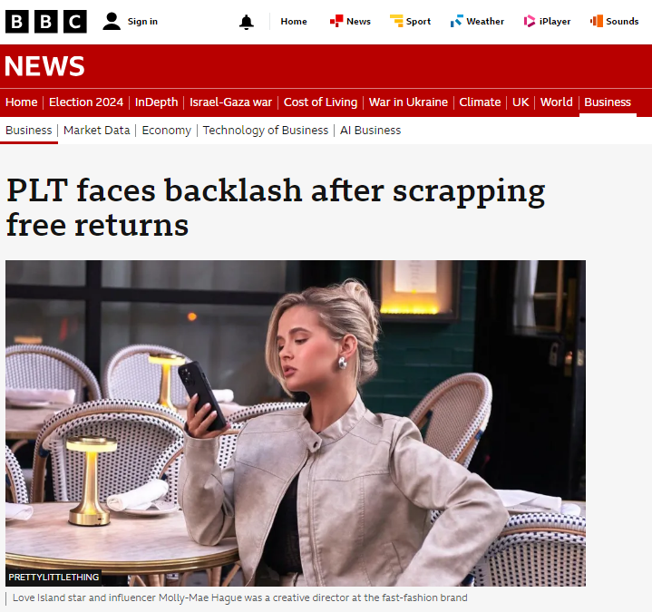

<https://www.bbc.co.uk/news/articles/c8vv062dm07o>