



A Level Business Studies (Edexcel)

Course Overview

**Link to specification:** <https://qualifications.pearson.com/content/dam/pdf/A%20Level/Business%20Studies/2015/specification-and-sample-assessment-materials/9781446914694_GCE2015_A_BUS_WEB.PDF>

**Textbooks**

# **Edexcel AS/A Level Business** by [Dave Hall](https://wordery.com/dave-hall-author), [Carlo Raffo](https://wordery.com/carlo-raffo-author),

# Revise Edexcel AS/A level Business Revision Guide & Workbook: includes online edition (REVISE Edexcel GCE Business 2015)

# 

These will be able to purchase from Business Studies Department when you start the course.

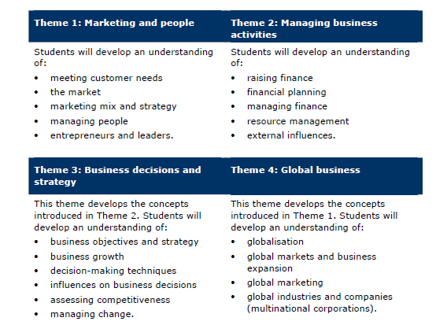**Throughout the course you will study:**

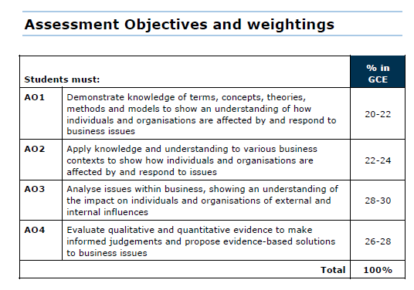

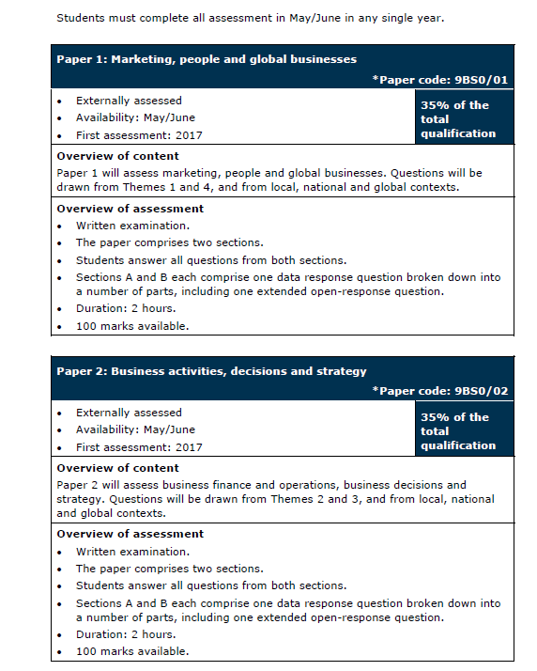

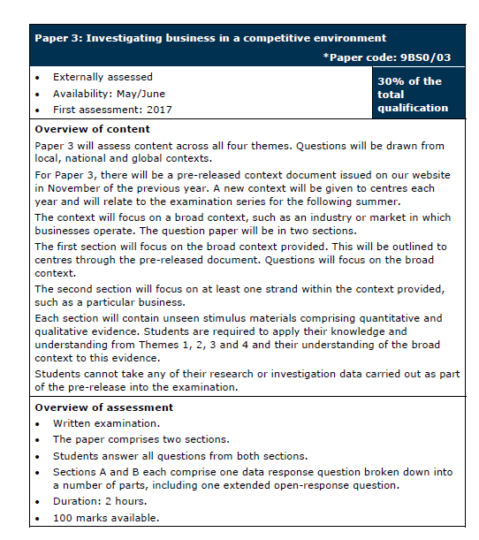

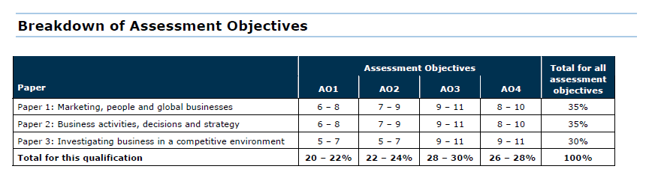



**Extra Resources**

**Websites:**

* [www.tutor2u.net](http://www.tutor2u.net)
* <https://www.youtube.com/c/TakingTheBiz>
* [**http://qualifications.pearson.com/en/qualifications/edexcel-a-levels/business-2015.html**](http://qualifications.pearson.com/en/qualifications/edexcel-a-levels/business-2015.html)
* [**www.revisionstation.co.uk**](http://www.revisionstation.co.uk)
* [**https://www.businessed.co.uk/**](https://www.businessed.co.uk/)
* [**www.businessstudiesonline.co.uk**](http://www.businessstudiesonline.co.uk)
* [**www.businesscasestudies.co.uk**](http://www.businesscasestudies.co.uk)
* [**http://www.bbc.co.uk/news/**](http://www.bbc.co.uk/news/)
* [**http://www.s-cool.co.uk/a-level/business-studies**](http://www.s-cool.co.uk/a-level/business-studies)

**News Articles**

Impact of Coronavirus: <https://www.tutor2u.net/business/reference/business-impact-and-response-to-thecoronavirus-crisis>

Impact of Coronavirus on cash flow and liquidity: <https://www.reuters.com/article/us-health-coronaviruseasyjet/big-uk-airlines-ground-most-of-their-fleets-to-survive-coronavirus-idUSKBN2130S9>

Non-price factors affecting demand: <https://www.bbc.co.uk/news/amp/business-52066454>

Corporate Social Responsibility: <https://www.tutor2u.net/business/reference/corporate-socialresponsibility-during-the-coronavirus-pandemic>

Food supply: <https://www.bbc.co.uk/news/business-52020648>

Agriculture, food supply and migration: <https://uk.reuters.com/video/watch/the-race-to-save-americasharvest-idOVC7O0TEN>

Oil industry retrenchment: <https://www.theguardian.com/business/2020/apr/01/bp-to-cut-spending-amidmost-brutal-oil-price-rout-in-decades>

## **Documentaries**

* The Nine to Five with Stacey Dooley - **BBC iPlayer**
* Tricky Business - <https://www.channel4.com/programmes/tricky-business>**Channel 4 On Demand**
* Beauty Laid Bare - **BBC iPlayer**
* The True Cost - **Netflix**
* Broken – Episode on IKEA - **Netflix**
* Flat pack empire – **BBC2 iPlayer**
* Inside Cadbury chocolate secrets unwrapped - <https://www.youtube.com/watch?v=BB3lJuMNUEk>
* Food unwrapped - **Channel 4 on demand**
* Inside the supermarket - <https://www.youtube.com/watch?v=_qwucutFTsQ>
* Panorama Amazon: What they know about us – **BBC iPlayer**
* Panorama Amazon: The Truth Behind the Click – **BBC iPlayer** and/or <https://www.youtube.com/watch?v=JwrUYS9UTeU>
* Pepsi vs Coke – **Amazon prime video**
* Jobs Vs Gates: The Hippie and The Nerd – **Amazon prime video**
* Starbuck unfiltered – **Amazon prime video**
* Facebook – Cracking the code – **Amazon prime video**
* Data centre the true cost of the internet – **Amazon prime video**
* Learn from The Experts - Jeff Bezos, Amazon Founder – **Amazon prime video**
* Learn from The Experts - Elon Musk, Tesla and SpaceX – **Amazon prime video**
* The millennial dream – **Amazon prime video**
* Business mindset for success – **Amazon prime video**
* Steve jobs – Billion Dollar Hippie – **Netflix**
* American Factory – **Netflix**
* Inside Waitrose – **Channel 5 on My5**
* Inside the factory – **BBC2**
* Dragons Den – **BBC2**

## **Films**

* The Founder – Dvd – **Amazon prime video or Netflix** – Franchising
* Deep Water Horizon – DVD - **Amazon prime video** – Ethical issues
* Trump – What’s the deal – **Amazon prime video**
* The Internship – **Amazon Prime video**
* The Social Network – **Netflix**
* The Big Short – **Netflix**
* The Great Hack – **Netflix**
* Enron: the smartest guys in the room – **Amazon Prime** and lots of analysis on YouTube

## **Books/Audiobooks**

* The Rise and Fall Of Marks & Spencer - and How It Rose Again – Judi Bevan
* What You See Is What You Get: My Autobiography - Alan Sugar
* Management in ten words - Terry Leahy
* Screw it lets do it – Richard Branson <https://www.youtube.com/watch?v=h9FkeyvdA2M>
* The Virgin Way – Richard Branson

Audio Book (free) - <https://www.youtube.com/watch?v=5wz40rdz7i4>

* The New One Minute Manager – Blanchard & Johnson

Audio Book (free) - <https://www.youtube.com/watch?v=ar4lrwXM4ao>